专科英语2 复习资料

Ⅰ. Matching 10’ (1*10)
1.university | A. 德国
2.Germany | B. By train
3. Resume | C. 与Can I help you?近义
4. What can I do for you? | D. 简历
5. Unfortunately | E. 大学
6. 坐火车 | F. 盼望
7. 颐和园 | G. Christmas
8. Look forward to | H. The Summer Palace
9. 圣诞节 | I. luckily的反义词
10. Turn left | J. 左转

1. ______ 2.______ 3.______ 4.______ 5.______
6. ______ 7.______ 8.______ 9.______ 10.______

Ⅱ. Simulated Situation 20’ (2*10)
Dialogue 1
A: Could you tell me where you graduated from?
B: ___________1____________
A: ___________2____________
B: My major was English.
A: What was your favorite subject?
B: __________3___________
A: Can you speak other foreign languages?
B: __________4___________
A:___________5__________
B: Three years ago.

A. When did you begin to learn French?
B. I graduated from the City University.
C. Yes, I can speak French.
D. Spoken English.
E. What was your major?

- ______ 2.______ 3.______ 4.______ 5.______

Dialogue 2
A: _________6_________
B: Nothing special, why?
A: We’d like to have you and your wife over for dinner this Saturday evening. ______7________
B: This Saturday evening?
A: Yes. And we hope you’ll be able to join us.
B: ______8________. We’d be very happy to come.
A: Good.
B: ________9_________
A: How does 7:00 sound?
B: _____10____. We’ll be looking forward for it.

A. Thank you for your invitation.
B. Are you doing anything Saturday evening?
C. Would you be able to come?
D. 7:00 is fine.
E. What time shall we plan to arrive?

6. ______ 7.______ 8.______ 9.______ 10.______

Ⅲ. Translation 10’(2*10)
- Kathy was, in fact, the least popular teacher in our college.
___________________________________________________________________
- 在他们的球队，判断球员总是根据他们在各种比赛中的表现。(judge)
___________________________________________________________________
- Old as they are, their hobbies remain unchanged.
___________________________________________________________________
- 他的履历使得这家公司很满意。(satisfied)
___________________________________________________________________
- This is how most parents see the only child these days.（独生子女）
___________________________________________________________________
6.如果你在大街上走失，不要迟疑快寻求帮助。
___________________________________________________________________
- Please remain silent and keep the books closed.
___________________________________________________________________
- 除非在特殊情况下，一般在课堂上都可以提问。
___________________________________________________________________
- Our city is would-famous for its historic buildings.
___________________________________________________________________
- 感谢你邀请我今天来进行面试。
___________________________________________________________________

Ⅳ. Reading 30’
Passage 1
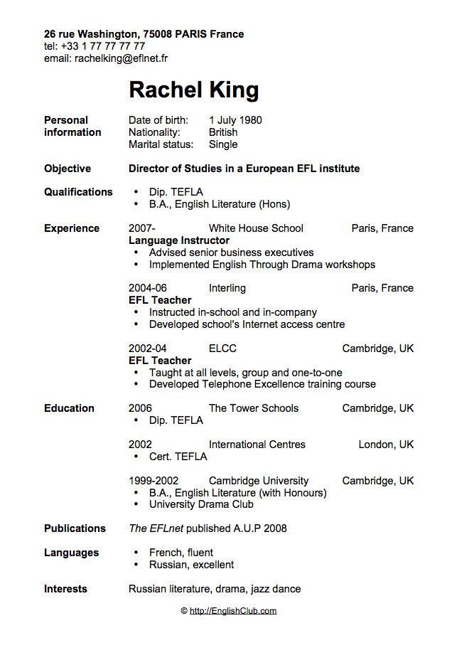
- Whose resume is it? ____________ (2’)
- What’s the applicant’s （申请者）job objective? __________ (2’)
- How long did the applicant work as EGL teacher in ELCC? ______ (1’)
- How many foreign languages does the applicant can speak? ( ) (2)
A. 1 B. 2 C. 3
- What are the applicant’s interests? (3’)
___________, ___________, __________.

Passage 2
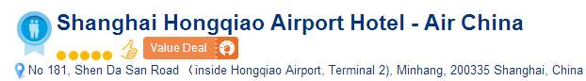
Located in the Terminal 2 of Hongqiao Airport, Shanghai Hongqiao Airport Hotel is the first hotel in China that offers exclusive airport check-in. Featuring free Wi-Fi in all areas, it is just steps from Hongqiao Railway Station and Hongqiao Airport metro station (line 2 and 10).
Hongqiao Airport Hotel is a 15-minute drive from Shanghai Zoo and a 10-minute drive from National (Shanghai) Center for Exhibition and Convention or Daduhui Golf Club. Jin'an Temple, People's Square and Yu Garden are all within a 25-minute subway ride of the property. Shanghai International Exhibition Centre is a 20-minute drive away.
We speak your language!
Hotel Rooms: 456
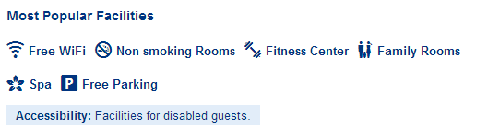
6. What’s the name of the hotel? _______________________(2’)
7. Where is the hotel located? _________________________(2’)
8. If you drive to Shanghai Zoo from the hotel, how long does it take? ( ) (2’)
A. 15 minutes B. 20 minutes C. 25 minutes
9. How many rooms does the hotel have? ______ (1’)
10. What are the most popular facilities in the hotel? (name three facilities) (3’)
_________, ___________, _________.

Passage 3
http://kaleidoscope.cultural-china.com/en/133Kaleidoscope12206_3.html
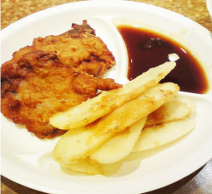
Nian Cake with Spare-ribs
New Year Cake with Spare-ribs is an economy and flavor snack with a history of more than 50 years in Shanghai. In the dish, the meat is tender and crisp, the cake is soft and tasty, and the gravy is rich and flavoured, which is really appetizing. The Xiao Changzhou Snack House at Sichuan Road of Fuzhou Road, and the Xiangdelai Snack House at Tibet Road are the best known places for its delicacy.
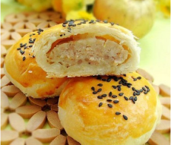
Pork-Filled Moon Cakes
Unlike the sweet, oily pastries that Chinese people eat during the Mid-Autumn Festival, pork mooncakes are a savory, meaty Shanghainese delicacy that is available all year around.
Eight Delicacies in Hot Sauce
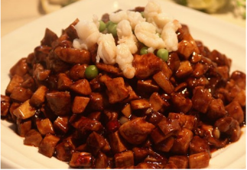
This is one of the most famous Shanghai local foods. It uses eight different raw food fried with delicious hot sauce, makes it tastes hot and sweet. In the famous Lv Bo Lang Restaurant in Yuyuan Bazaar, the best and the most traditional Eight Delicacies in Hot Sauce can be found here.
- How many years of history does New Year Cake with Spare-ribs have? ( ) (2’)
A. 10 years B. 30 years C. More than 50 years
- What are the two best known places for New Year Cake with Spare-rib? (2’)
___________________, __________________.
13. When is pork mooncakes available? ( ) (2’)
A. During the Mid-Autumn Festival B. Autumn C. All year around
14. What is Lv Bo Lang Restaurant famous for? _______________ (2’)
15. Where is Lv Bo Lang Restaurant? ______________. (2’)
V. Writing 20’
你想邀请Tom参加你的生日聚会（时间、地点自定）。请写一封邀请函给Tom。请注意邀请函的格式。
_____________________________________________________________________________________________________________________________________________________________________________________________________________________________________________________________________________________________________________________________________________________________________________________________________________________________________________________________________________________________________________________________________________________________________________________________________________________________________________________________________________________________________________________________________________________________________________________________________________________________________________________________________________________________________

答案：
Ⅰ. Matching 10’ (1*10)
1. __E____ 2.___A___ 3.___D___ 4.____C__ 5.___I___
6. ___B___ 7.___H___ 8.____F__ 9.___G___ 10.___J___

Ⅱ. Simulated Situation 20’ (2*10)
1. __B____ 2.___E___ 3.___D___ 4.___C___ 5.___A___
6. ___B___ 7.___C___ 8.___A___ 9.___E___ 10.___D___

Ⅲ. Translation 10’(2*10)
- Kathy was, in fact, the least popular teacher in our college.
实际上凯西是我们学校最不受欢迎的老师。
- 在他们的球队，判断球员总是根据他们在各种比赛中的表现。(judge)
In their team, players are always judged by their performance in all kinds of games.
- Old as they are, their hobbies remain unchanged.
尽管他们年纪大了，但是他们的爱好还是没变。
- 他的履历使得这家公司很满意。(satisfied)
His resume makes the company satisfied.
- This is how most parents see the only child these days.（独生子女）
这就是目前多数家长对待独生子女问题的方式。
6.如果你在大街上走失，不要迟疑快寻求帮助。
If you get lost on street, do no hesitate to seek help.
- Please remain silent and keep the books closed.
请保持安静，不要打开书本。
- 除非在特殊情况下，一般在课堂上都可以提问。
Except on special occasions, it’s all right to question in class.
- Our city is would-famous for its historic buildings.
我们这座城市因其古建筑而世界闻名。
- 感谢你邀请我今天来进行面试。
Thank you for inviting me to the interview.

Ⅳ. Reading 30’
- Whose resume is it? ____Rachel King________ (2’)
- What’s the applicant’s （申请者）job objective? __Director of Studies in a European EFL Institute________ (2’)
- How long did the applicant work as EGL teacher in ELCC? ___2 years___ (1’)
- How many foreign languages does the applicant can speak? ( B ) (2)
A. 1 B. 2 C. 3
- What are the applicant’s interests? (3’)
___Russian literature________, ____drama_______, ____jazz dance______.
6. What’s the name of the hotel? ____Shanghai Hongqiao Airport Hotel________(2’)
7. Where is the hotel located? __Located in the Terminal 2 of Hongqiao Airport__(2’)
8. If you drive to Shanghai Zoo from the hotel, how long does it take? ( A ) (2’)
A. 15 minutes B. 20 minutes C. 25 minutes
9. How many rooms does the hotel have? ___456___ (1’)
10. What are the most popular facilities in the hotel? (name three facilities) (3’)
___Free Wi-Fi______, _Non-smoking rooms__________, ____Fitness center_____.
- How many years of history does New Year Cake with Spare-ribs have? ( C ) (2’)
A. 10 years B. 30 years C. More than 50 years
- What are the two best known places for New Year Cake with Spare-rib? (2’)
The Xiao Changzhou Snack House at Sichuan Road of Fuzhou Road, and the Xiangdelai Snack House at Tibet Road.
13. When is pork mooncakes available? ( C ) (2’)
A. During the Mid-Autumn Festival B. Autumn C. All year around
14. What is Lv Bo Lang Restaurant famous for? ___Eight Delicacies in Hot Sauce___(2’)
15. Where is Lv Bo Lang Restaurant? ___in Yuyuan Bazaar_______. (2’)

V. Writing 20’
Dear Tom,
My birthday is coming soon. I am planning to have a birthday party on Sunday, June 1 st, at six p.m. The party will be held in my house.
I’d very much to have you come. We haven’t seen each other for a long time.
Please let me know if you’ll be able to join us.

Yours,
Anna

